
NEWSLETTER NUMBER 1 - 10.11.2011
ST MATTHEW’S RESIDENTS’ ASSOCIATION (Encompassing St. Matthews Avenue; Kingsdowne Road; Chamberlain Way; 19-39 Upper Brighton Road; Iris Close and the north side of Ditton Road in Surbiton)
Dear Residents,
Welcome to the first newsletter from your new committee. We were voted in at the Extraordinary Committee Meeting on 5th April 2011 at St Matthew’s church. We are:
- Tim Snow (at number 18 St Matthews Avenue) who is the Chairman;
- David Gander who is the Secretary;
- Louise Beattie who is the Treasurer;
and
- James Gill who is a Committee Member.
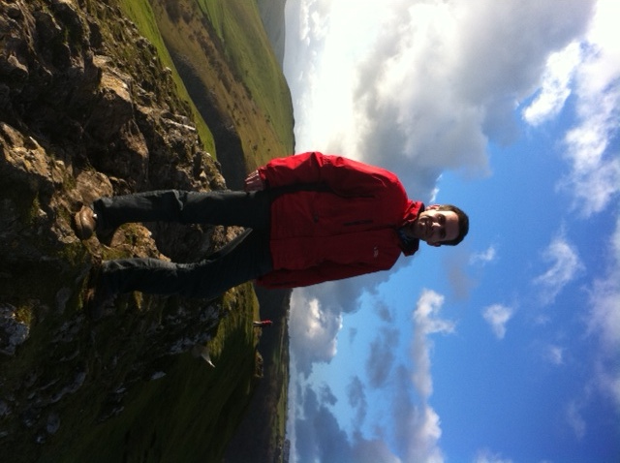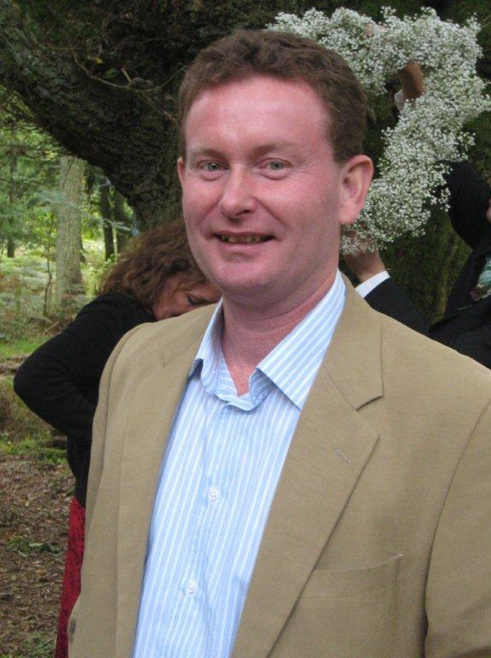
We are passionate about improving as well as protecting our local area for residents.
We intend to build relationships with the surrounding residents’ committees; the police; the council; and local councillors so we understand local issues and how they may affect us. As a result of this activity we shall consult regularly with you on local issues. Ideally we’d like to email you to save the cost of printing so we would be grateful if you could let us know your email address.
We’re keen to spend our time on the things that matter to you and therefore we would be grateful if you could respond to our questionnaire. We’ve kept it simple but please do feel free to add issues that you would like us to consider.
We have already set up a website which is www.stmatthewsra.org.uk. We intend to use that website to publish our newsletter (in addition to posting to you); update you on the outcome of the questionnaire and keep you regularly updated on the progress we are making and have made. We also intend to have General Meetings every 6 months so we report back to you on progress as well as discuss issues with you. This website can be used to communicate with us and we’d value feedback on the site.
In addition we are keen to appoint a representative for each road that the Residents’ Association represents as we acknowledge the Committee are all based in St Matthews Avenue. This involves attending the Committee meetings from time to time to ensure we represent each road fairly. Please let us know if that interests you.
St Matthew’s Residents’ Association Questionnaire
Questionnaire Purpose: To understand what is important to Residents, in order for the Committee to focus its time on the most important issues.
Respondent’s Name:
Respondent’s Address (House number and street):
Respondent’s email address if you have one:
Instructions:
- Please circle what is important to you (These items emerged as important to some residents at the last General meeting of the association).
- If you have any other issues that you would like us to consider please add these below
- Please respond to us by 22nd November 2011 either by:
  - Emailing this to us at: committee@stmatthewsra.org.uk
  - Post to Tim Snow, 18 St Matthews Avenue, Surbiton
  - Responding via our website www.stmatthewsra.org.uk

- Campaigning for the resurfacing of local roads

- Campaigning for a Pedestrian crossing at the end of Kingsdowne Road and/or Ditton Road (next to the Europa Ski Lodge)

- Campaigning for the re-surfacing of the pavements

- Commemorating the Queen’s Jubilee in some form of event

- Fund raising for local charities

- Anything else – please add:

- How would you prefer to receive our updates?

Through your door via email/ website Not at all

- We would also like to have an introductory meeting and Christmas social at St Matthew’s Church hall, over the Christmas period. Would you attend?

Yes Maybe No

